Name: ________________________________________________________________________________

Unit 2: Microeconomics

Main Topics: Supply, Demand and Price

CHAPTER 4 – Demand

**SSEMI2 The student will explain how the Law of Demand, the Law of Supply, prices, and profits work to determine production and distribution in a market economy.**

a. Define the Law of Supply and the Law of Demand.

b. Describe the role of buyers and sellers in determining market clearing price.

c. Illustrate on a graph how supply and demand determine equilibrium price and quantity.

d. Explain how prices serve as incentives in a market economy.

**SSEMI3 The student will explain how markets, prices, and competition influence economic behavior.**

a. Identify and illustrate on a graph factors that cause changes in market supply and demand.

b. Explain and illustrate on a graph how price floors create surpluses and price ceilings create shortages.

c. Define price elasticity of demand and supply.

Activator – Ch. 4

Three people enter a Mazda dealership all interested in buying a brand new car. All three initially stop to look at the Mazda RX8. The first person tells the salesperson that they “really like the RX8” but they “don’t have any money today”, and are “saving their money for a purchase within the next 6 months”. The second person tells the dealer that they “have the money to buy”, they “are going to ultimately buy RX8”, but they are shopping various dealerships and are “not willing to buy today”. The third person tells the dealer that they “love the RX8!”, they “have the money” and they “want to buy it today.”   
Answer the following based on the above scenario:

1. Next to each customer, write each of the following that apply to their situation:
   1. Desire to buy
   2. Willingness to buy
   3. Ability to buy
2. Customer 1 ____________________________________________________________________________________
3. Customer 2 ____________________________________________________________________________________
4. Customer 3 ____________________________________________________________________________________
5. Which customer do think was most appealing to the salesperson, and why? ________________________________  
   ______________________________________________________________________________________________
6. Which customer would you have helped first, and why? ________________________________________________  
   ______________________________________________________________________________________________

Chapter 4 – The Market Forces of Supply and Demand

Section 1 – Understanding Demand

* Demand – ____________________, ability, and _____________________________________ to buy a good/service
  + The amount of a product that a ____________________________ (individual) or _____________________  
    ____________________________ (market) will purchase at a given price
  + In a market system, ___________________________________________ determines the prices of goods based on _______________________________________________
* Microeconomics – The study of the economic behavior and decision making _________________________________  
  _______________________________________________________________________________________________

Application Chart – Demand

Make a three column chart that represents 3 items that you want on one side, whether you can afford them or not in the next, and whether you are willing to buy them in the last.

|  |  |  |  |
| --- | --- | --- | --- |
| Desired Items | Ability/Afford | Willingness | Demand |
| 1.  2.  3. |  |  |  |

The Law of Demand

* Law of Demand – prices are _________________________, consumers will _____________________________; prices are ____________________________, consumers will buy ___________________________.
  + ____________________________________________ relationship between price and the QD of a product.
  + Prices __________________________________________________________________________________

The Income Effect

* Income Effect – the change in _______________________________________________   
  “more ___________________________________”
* Consumers feel ___________________________ when prices drop, _____________________________ when prices rise. Both scenarios affect the __________________________________________ of a product.

Substitution Effect

* Substitution Effect – when consumers react to an increase in a good’s price by consuming _____________________  
  ______________________________________and _____________________________________________________

The Demand Schedule

* Demand Schedule - a table that lists the _________________________________________________ will purchase at each price in the market
* Market Demand Schedule - lists the quantity of a good that _____________________________________________ at each price in the market

Application - The Demand Curve

* Demand curve - graphically represents the _______________________________________
  + Demand Curve is _________________________________ sloping because of the law of demand
* Plot the demand schedule below, which represents 2004 Florida Marlins avg. sales per game (in thousands)



|  |  |
| --- | --- |
| Price | Quantity |
| $3.00 | 0 |
| 2.50 | 2 |
| 2.00 | 4 |
| 1.50 | 6 |
| 1.00 | 8 |
| .50 | 10 |
| .10 | 12 |

Application – Shifts of the Demand Curve

|  |  |  |  |
| --- | --- | --- | --- |
| Price | 2004 |  |  |
| $40 | 0 |  |  |
| 35 | 4 |  |  |
| 30 | 6 |  |  |
| 25 | 8 |  |  |
| 20 | 10 |  |  |
| 15 | 12 |  |  |
| 10 | 14 |  |  |

Section 2 - Shifts of the Demand Curve

* Changes in Demand are reflected as a _______________________________________________________________
* Shifts to the right indicate an__________________________________in demand
* Shifts to the left indicate a __________________________________ in demand

Difference Between A Change in Quantity Demanded and a Change in Demand

* QD - A change in the amount a consumer will purchase _________________________________________________
  + Ceteris paribus – all other things _______________________, all things ______________________________________
  + Reflected as ________________________________________________
* D – A change in the amount a person will buy as a result of an _________________________________ (change in ceteris paribus - popularity of product, consumer income, etc.), not having to do with _______________________
  + Reflected as a __________________________________

What Causes Shifts in the Demand Curve?

Income

* Consumer Income – A consumer’s income affects their ________________________________________________
* __________________________________in income will cause an ­­­­­­­­­­­­­­­____________________________ in consumption
* __________________________________in income will cause an ­­­­­­­­­­­­­­­____________________________ in consumption
* Normal good – income _________________________, demand _________________________
* Inferior good – income _________________________, demand rises _______________________

Price of Related Goods

* Price of related goods – demand for goods can be affected by _____________________________________________________
* Complements – the demand of one good ____________________________________________________________
* Substitutes – the demand for one good decreases because ______________________________________________

Consumer Tastes and Advertising

* Consumer Tastes – changes in ________________________________________________________, the   
  ________________________________________________
* Advertising – influence of _________________and ______________________________________________ can affect demand

Consumer Expectations

* Consumer Expectations – refers to ________________________________________________, as it relates to consumption
* Expectations for the future can ____________________________________________________________________

Number of Buyers

* Population – an increase in the ________________________________________________ can cause an ________________________________________________________in the demand for products
* ____________________________________ in population, ____________________________________ in demand
* ____________________________________ in population, ____________________________________ in demand

Shift in Market Demand Curve for SUV’s

Application – Average sales of SUV’s per month (in thousands)

* Plot the demand schedule below. The graph represents the demand for SUV’s during the early 1990’s. During the late 1990’s SUV’s became increasingly popular in the United States. During the mid 2000’s, gas prices increased nationally to average rates around 5.00 per gallon, which affected the demand for SUV’s around the country.



|  |  |  |  |
| --- | --- | --- | --- |
| Price | Early 90’s | Late 90’s | After Gas Hikes |
| $55 | 0 | 2 | 0 |
| 50 | 2 | 4 | 1 |
| 45 | 4 | 6 | 2 |
| 40 | 6 | 8 | 3 |
| 35 | 8 | 10 | 4 |
| 30 | 10 | 14 | 6 |
| 25 | 14 | 20 | 8 |

1. How did the curve change from the early 90’s to the late 90’s? ___________________________________________
2. What was the cause of the change from the early 90’s to the late 90’s? ____________________________________
3. What happened to the curve after the gas hikes? ______________________________________________________

Section 3 – Elasticity of Demand

**Activator – Chapter 4 Section 3**

1. List 2 items that you would buy less of if the price increased
   1. ______________________________________________________
   2. ______________________________________________________
2. List 2 items that you would buy more of if the price decreased
   1. ______________________________________________________
   2. ______________________________________________________
3. List 2 items that you would continue to buy, even if the increased
   1. ______________________________________________________
   2. ______________________________________________________

**Section 3 – Elasticity of Demand**

* Elasticity of Demand –how consumers will ____________________________ or ____________________________ their quantity demanded _________________________________________________________________________
* Measures the __________________________________________________________________________________
* Helps determine how much a ______________________________________________________________________

**Elastic Demand**

* Elastic – consumption changes _____________________________________________________________________
* A consumer is __________________________________________________________________________________

**Inelastic Demand**

* Inelastic - changes in price causes a _________________________________________________________________
* Consumers continue to ___________________________________________________________________________

**Determinants of Demand Elasticity**

1. __________________________________________________
   * Pepsi/_______________, Butter/_________________________
2. __________________________________________________
   * How much you ____________________________________________
   * Table salt versus ____________________________________________
3. __________________________________________________
   * Medicine versus a __________________________________________
4. __________________________________________________
   * Longer time horizon – __________________________________________
   * Gas in the short run is ____________________________,   
     but over time _____________________________

**Values of Elasticity**

* Elasticity has a precise mathematical definition

Percentage change in quantity demanded

Percentage change in price

* Value is less than 1, it is considered _________________________________
  + Inelastic – ________________________________________
* Value is greater than one, demand is _________________________________
  + Elastic – ________________________________________
* Value is equal to one, demand is __________________________________
  + Unitary Elastic – ________________________________________

**The Midpoint Method**

Price Elasticity = (Q2 – Q1) / [(Q2+Q1) / 2]  
 (P2 – P1) / [(P2 + P1) / 2]

**Application – Elasticity of Ice Cream Cones**

**Application – Elasticity of Table Salt**

Elasticity Application 1 – Ice Cream Cones

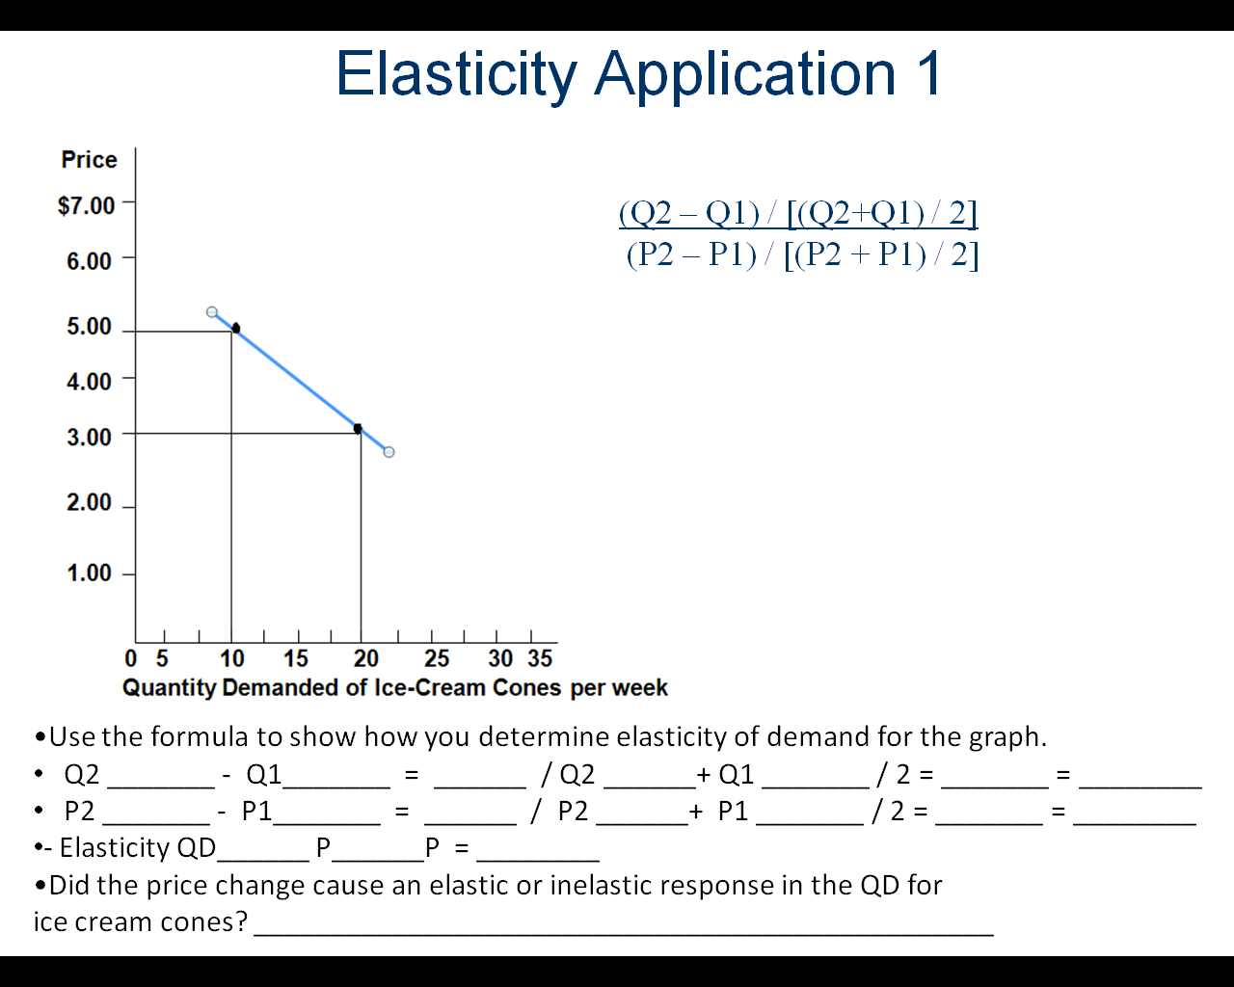

Elasticity Application 2 – Insulin

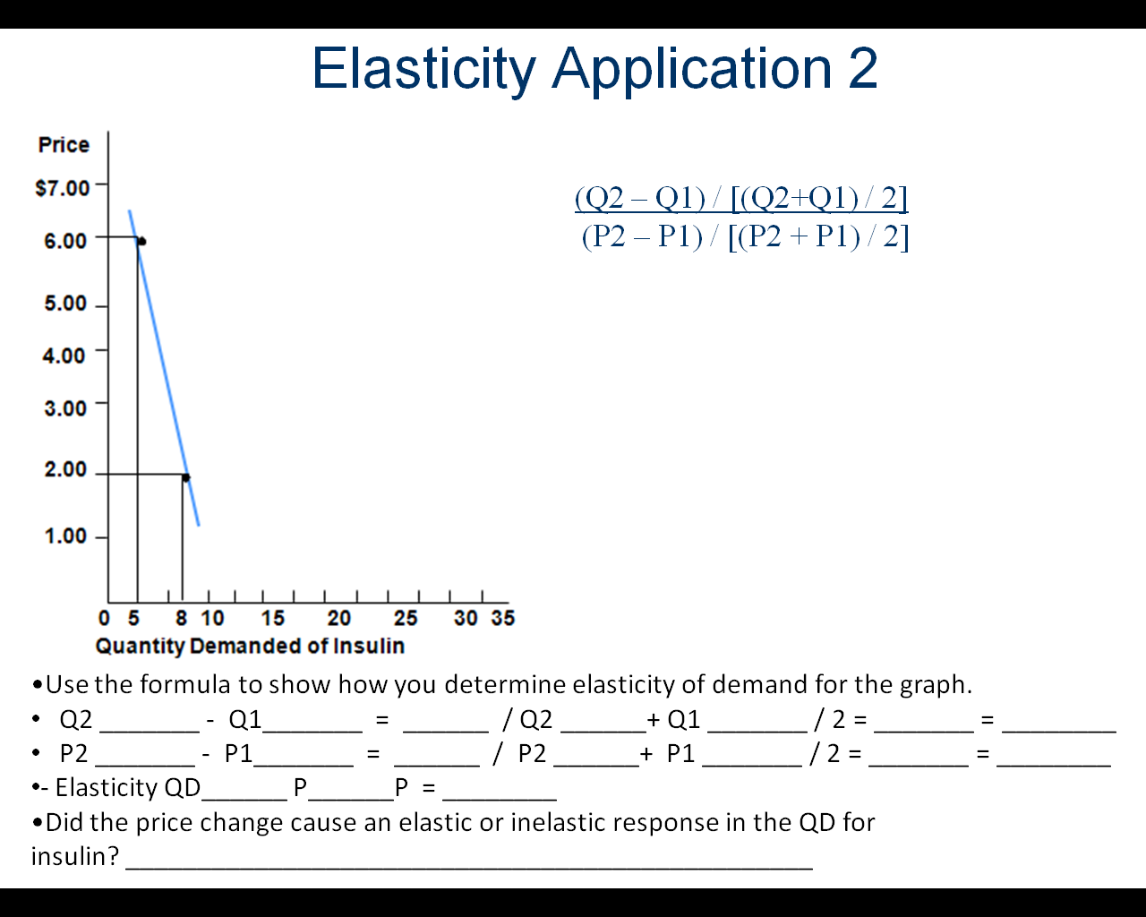

Elasticity Application 3 – Apple

